Comparative Genomic Re-analysis of Exiguobacterium profundum Strain TSS-3: Toward a Genomic Basis for Anti-Inflammatory Carotenoid Activity
Afnan Asharaf
MSc Microbiology (St. Mary's Autonomous College, Thrissur, University of Calicut) · CSB Internship Programme, CVJ Centre for Synthetic Biology and Biomanufacturing (CUSAT-TBI, Kochi) · GenBank depositions: PZ163764, PZ163949, PZ163977 · ASM Member
Document status: all planned analysis stages complete (QC, trimming/filtering, assembly, completeness assessment, annotation, biosynthetic gene cluster mining, comparative genomics).

Abstract
Exiguobacterium profundum is an environmentally versatile bacterial species recovered from diverse extreme habitats. This study independently reproduces and extends a published hybrid genome assembly and annotation pipeline for E. profundum strain TSS-3, isolated from a saline-alkaline spring (Chiapas, Mexico), using published raw Illumina and Oxford Nanopore sequencing data. Following quality control, trimming, and long-read filtering, hybrid assembly (Unicycler) produced a complete, circularized chromosome (2,880,082 bp) and a small plasmid (4,645 bp), closely matching the originally published assembly (QUAST: 100% genome fraction, 0 misassemblies against the reference). Genome completeness assessment (CheckM) confirmed a highly complete and uncontaminated assembly (99.34% completeness, 0.66% contamination). Genome annotation (Prokka) identified 2,936 coding sequences, consistent with the originally reported annotation (2,900 CDS). Biosynthetic gene cluster mining (antiSMASH) identified a terpene-precursor region and a terpene region containing carotenoid biosynthesis genes (crtB, crtN, crtNb, crtNc), corresponding to the C30 (diapocarotenoid) branch of bacterial carotenoid biosynthesis. Average Nucleotide Identity analysis against the E. profundum type strain (96.21% ANI) confirmed species-level identity. These results independently validate a published bacterial genome assembly using entirely free, cloud-based computational tools, and identify native carotenoid biosynthetic capacity in TSS-3 that provides genomic context — though not a direct compound-level match — for anti-inflammatory carotenoid activity previously characterized experimentally in a related E. profundum isolate (strain PZ163977).

1. Introduction
Exiguobacterium profundum is a halotolerant, environmentally versatile bacterial species first isolated from deep-sea hydrothermal vent environments and subsequently reported from a range of extreme habitats, including saline springs and coastal marine sediments. During my MSc dissertation research, I isolated an E. profundum strain (PZ163977; GenBank accession PZ163977) from coastal fish water in Kerala, India, and characterized its bioactivity profile. GC-MS analysis of strain PZ163977 identified carotenoid pigments, including astaxanthin and lycoxanthin, alongside 13-docosenamide (erucamide). Biochemical assays demonstrated anti-inflammatory activity via COX-2 inhibition (quantitative results withheld pending separate publication of the dissertation work).
A subsequent comparative genomics study (16S rRNA phylogenetics, pan-genome analysis, and antimicrobial resistance profiling across ten Exiguobacterium genomes) was conducted using the BV-BRC platform, placing PZ163977 within a marine/environmental clade of the genus.
The present project extends this work by independently re-analyzing publicly available whole-genome sequencing data for a closely related strain, E. profundum TSS-3, isolated from a saline-alkaline spring in Chiapas, Mexico (Rincón-Rosales et al., 2023). TSS-3 and PZ163977 are the same species from geographically and environmentally distinct sources, making TSS-3 a natural comparator for examining which genomic features — particularly biosynthetic gene clusters for carotenoid biosynthesis — are conserved across the species versus specific to individual strains or environments.
The specific aims of this re-analysis are to: (i) independently reproduce a published bacterial genome assembly and annotation pipeline using public raw sequencing data; (ii) identify biosynthetic gene clusters (BGCs) in the TSS-3 genome, in particular any terpene/carotenoid cluster; and (iii) evaluate whether the presence of such a cluster in TSS-3 provides genomic-level support for the anti-inflammatory carotenoid bioactivity measured experimentally in strain PZ163977.

2. Materials and Methods

2.1 Data source
Raw Illumina and Oxford Nanopore sequencing reads for E. profundum TSS-3 were retrieved from the NCBI Sequence Read Archive under BioProject PRJNA887767 (Rincón-Rosales et al., 2023, Microbiology Resource Announcements 12:e00171-23). Two sequencing runs were used: SRR24916835 (Illumina NovaSeq 6000, paired-end, 150 bp, 12,134,956 read pairs) and SRR24916834 (Oxford Nanopore MinION, 64,387 reads, read lengths 43 bp–141,385 bp). The published complete genome assembly for this BioProject (GCA_029026745.1) was retained for use as a reference in downstream assembly quality assessment.
Deviation from planned protocol: raw reads were retrieved by direct HTTP download of FASTQ files from the European Nucleotide Archive (ENA), rather than via the Galaxy "Faster Download and Extract Reads in FASTQ" (fasterq-dump) tool as originally planned. The Galaxy SRA-download tool failed to complete on the available public server instance; direct ENA retrieval was used as a reliable substitute and produced identical raw read data (verified by matching read counts and file sizes to the SRA metadata records).

2.2 Quality control
Read quality was assessed using FastQC v0.12.1 (Galaxy toolshed wrapper) for all three raw read files (Illumina R1, Illumina R2, and Nanopore). Standard FastQC modules were reviewed, including per-base sequence quality, per-sequence GC content, sequence duplication levels, and adapter content.

2.3 Illumina read trimming
Illumina paired-end reads were trimmed using Trimmomatic v0.39 (paired-end mode) with the following parameters: ILLUMINACLIP (TruSeq3-PE adapter set; seed mismatches = 2, palindrome clip threshold = 30, simple clip threshold = 10, minimum adapter length = 8, keep-both-reads = true), LEADING:3, TRAILING:3, SLIDINGWINDOW:4:15, MINLEN:50.
Deviation from planned protocol: Trimmomatic's automatic quality-encoding detection failed on the Galaxy server ("Error: Unable to detect quality encoding"), causing initial job failures. This was resolved by explicitly specifying Phred33 encoding, which matched the Sanger/Illumina 1.9 encoding already confirmed by the prior FastQC run. All reported trimming results reflect the corrected, successful run.
Only the paired output files (forward and reverse reads with both mates surviving trimming) were retained for downstream assembly; unpaired output files were discarded.

2.4 Nanopore read filtering
Nanopore long reads were filtered using Filtlong v0.3.1 with a minimum read length of 500 bp and a minimum mean quality score of 7 (--min_length 500 --min_mean_q 7).
Deviation from planned protocol: NanoFilt, originally specified for this step, was not available as an installed tool on the Galaxy instance used (usegalaxy.org). Filtlong was substituted as a functionally equivalent long-read length/quality filtering tool, using threshold parameters (minimum length 500 bp, minimum mean quality 7) matched to the original NanoFilt protocol.

2.5 Genome assembly
Hybrid genome assembly of trimmed Illumina and filtered Nanopore reads was performed using Unicycler v0.5.1 (normal bridging mode, default parameters; SPAdes v4.0.0 used internally for the short-read assembly graph), matching the assembly method used in the original TSS-3 genome publication. The assembly completed in 4 hours 4 minutes (Galaxy, usegalaxy.org).

2.6 Assembly quality assessment
Assembly structural quality was assessed using QUAST v5.3.0, with the published TSS-3 assembly (GCA_029026745.1) supplied as the reference genome for alignment-based comparison. Default QUAST thresholds were used (minimum contig length 500 bp, minimum alignment identity 95%). Genome completeness and contamination were independently assessed using CheckM v1.0.18 (lineage-specific workflow, run via KBase), which compares recovered marker genes against a database of lineage-specific single-copy genes.
Deviation from planned protocol: the reference assembly (GCA_029026745.1) was retrieved by direct download from the NCBI genomes FTP site rather than through a Galaxy reference-fetching tool, for consistency with the ENA-based raw read retrieval approach described in Section 2.1.

2.7 Genome annotation
The assembled genome was annotated using Prokka v1.14.6, with genus- and species-specific settings (Kingdom: Bacteria; Genus: Exiguobacterium; Species: profundum; Strain: TSS-3; genus-specific BLAST database enabled). rRNA and tRNA prediction (Barrnap, Aragorn) and ncRNA searching (Infernal + Rfam) were enabled.

2.8 Biosynthetic gene cluster mining
Biosynthetic gene clusters (BGCs) were identified using antiSMASH v8.0.4 (relaxed detection strictness), with the Prokka-generated GenBank (.gbk) file supplied as input. ClusterBlast, KnownClusterBlast, and SubClusterBlast comparison modules were enabled to assess similarity to characterized clusters in the MIBiG database.

2.9 Comparative genomics (Average Nucleotide Identity)
Average Nucleotide Identity (OrthoANIu algorithm) between the TSS-3 assembly and the E. profundum type strain 10C (GCF_025234635.1) was calculated using the EzBioCloud ANI Calculator. The type strain reference genome was retrieved from the NCBI genomes FTP site.

3. Results

3.1 Read quality control
Basic Statistics and quality metrics for all three raw read datasets are summarized in Table 1.
Dataset | Reads | Total bases | Mean quality | GC% | Notes
Illumina R1 (SRR24916835_1) | 12,134,956 | 1.8 Gbp | Q30–31 | 48 | No adapter contamination detected
Illumina R2 (SRR24916835_2) | 12,134,956 | 1.8 Gbp | Q30–31 | 48 | Minor GC-content deviation flagged (not contamination)
Nanopore (SRR24916834) | 64,387 | 583.8 Mbp | Lower/variable (platform-typical) | 47 | Length range 43 bp–141 kb; WARN/FAIL flags typical for Nanopore chemistry
Table 1. Summary quality metrics from FastQC v0.12.1 for raw Illumina and Nanopore read datasets.
Measured GC content for all three datasets (47–48%) closely matched the published TSS-3 chromosome GC content (48.16%), indicating no detectable cross-contamination from a different organism.
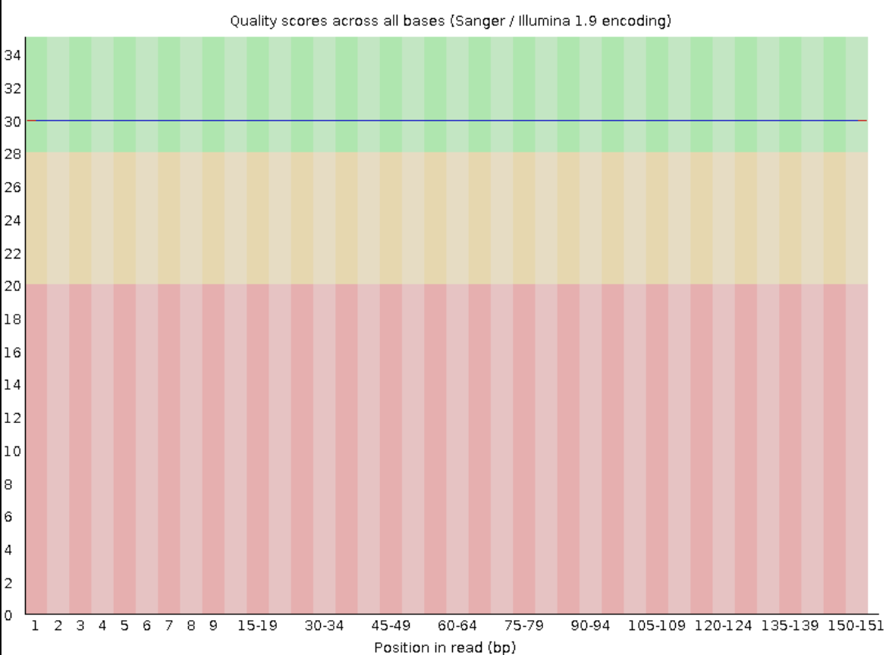
Figure 1. Per-base sequence quality, Illumina R1 (SRR24916835_1).
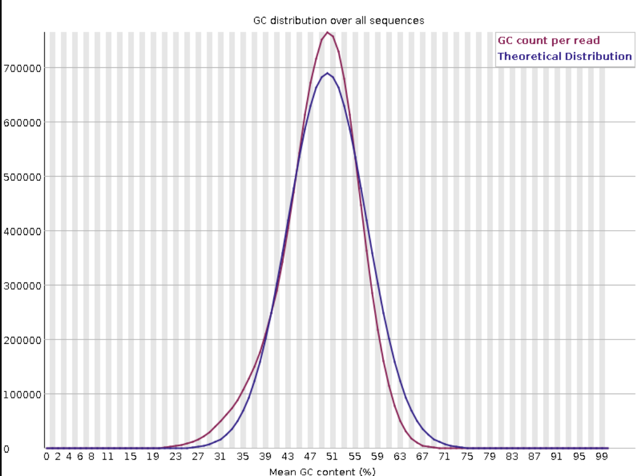
Figure 2. Per-sequence GC content, Illumina R1 (SRR24916835_1).
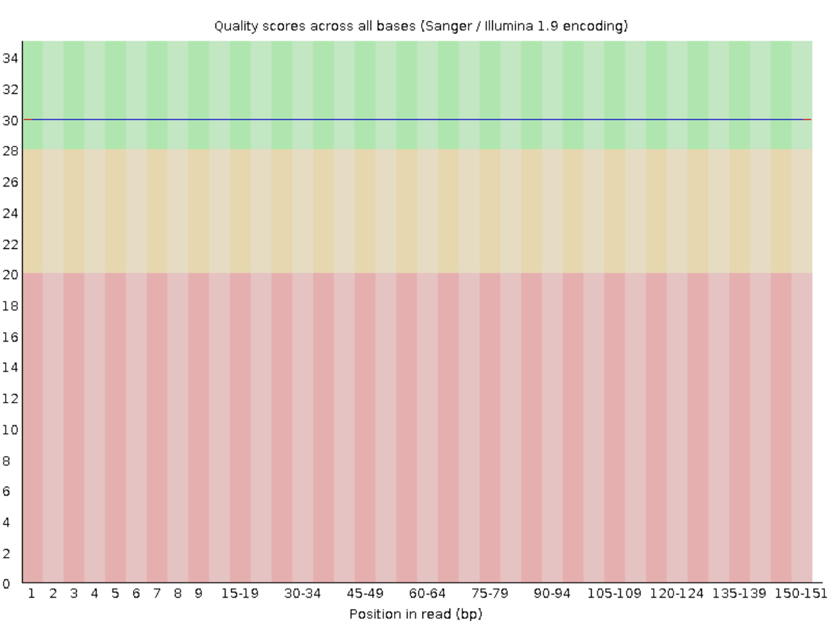
Figure 3. Per-base sequence quality, Illumina R2 (SRR24916835_2).
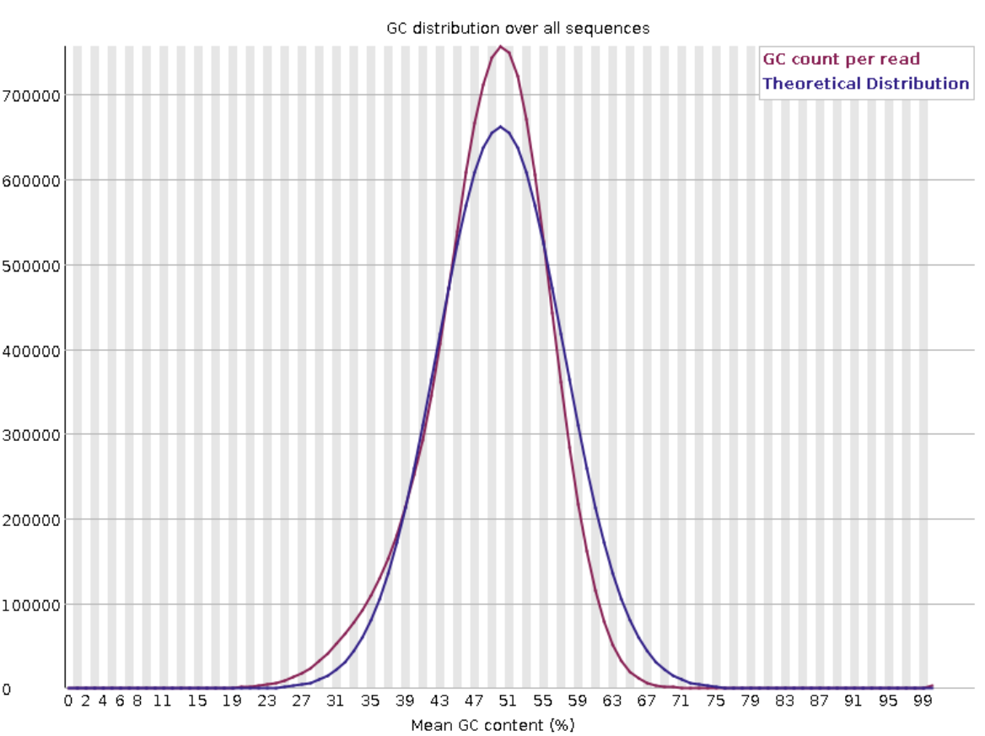
Figure 4. Per-sequence GC content, Illumina R2 (SRR24916835_2).
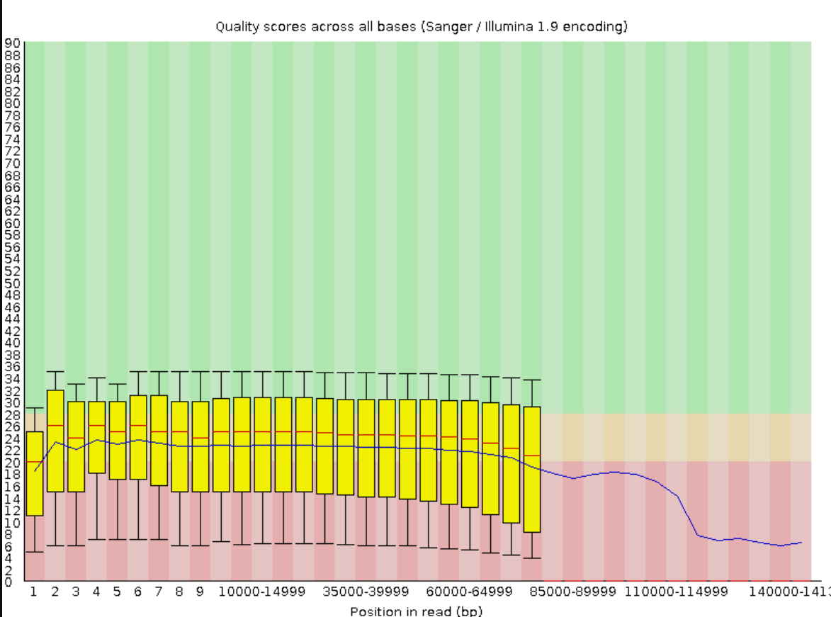
Figure 5. Per-base sequence quality, raw Nanopore reads (SRR24916834).
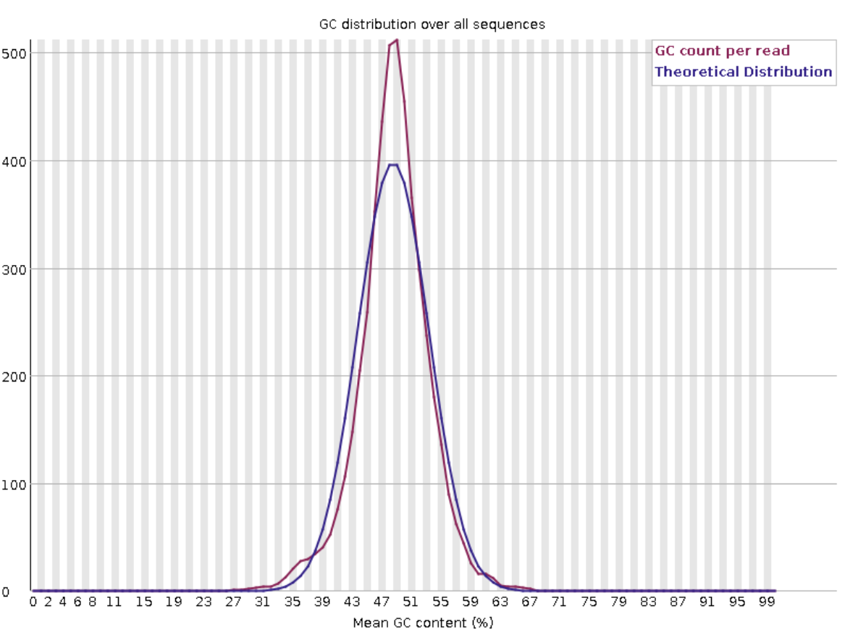
Figure 6. Per-sequence GC content, raw Nanopore reads (SRR24916834).

3.2 Illumina read trimming
Trimmomatic trimming of Illumina paired-end reads retained the overwhelming majority of input data:
Metric | Value
Input read pairs | 12,134,956
Both surviving | 12,134,888 (100.00%)
Dropped | 68 (0.00%)
Table 2. Trimmomatic v0.39 output summary for Illumina paired-end reads.
The near-complete survival rate is consistent with the high baseline read quality observed by FastQC (Section 3.1).

3.3 Nanopore read filtering
Filtlong filtering of raw Nanopore reads (minimum length 500 bp, minimum mean quality 7) removed a modest fraction of reads by count while retaining nearly all sequence content by base pairs:
Metric | Before filtering | After filtering | Retained
Reads | 64,387 | 59,061 | 91.7%
Total bases | 583.8 Mbp | 582.1 Mbp | 99.7%
Table 3. Filtlong v0.3.1 filtering summary for Nanopore reads.
The reads removed by filtering were predominantly short, low-information fragments below the 500 bp length threshold; total sequence content (bp) was almost entirely preserved (99.7%), indicating minimal loss of useful long-read data.
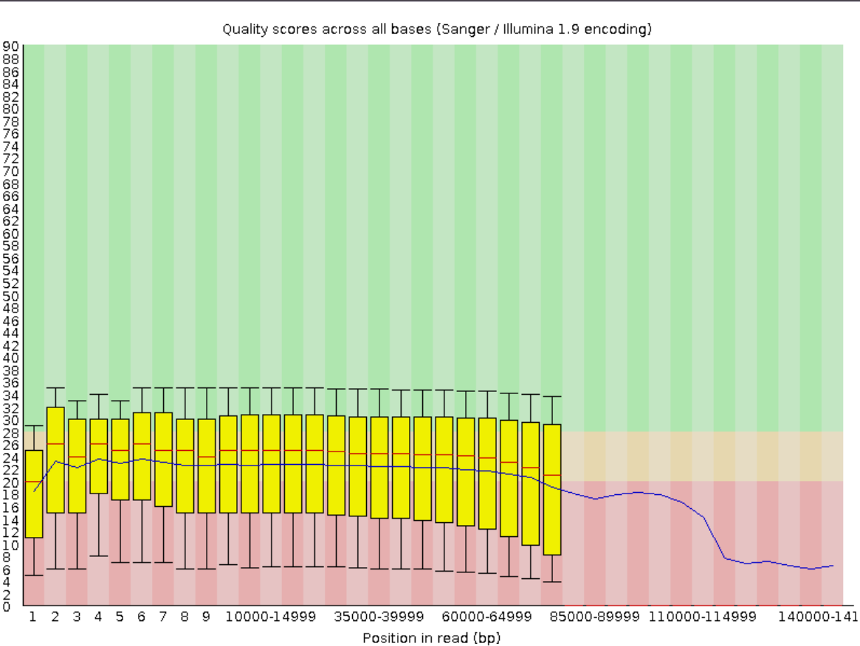
Figure 7. Per-base sequence quality, filtered Nanopore reads (post-Filtlong).
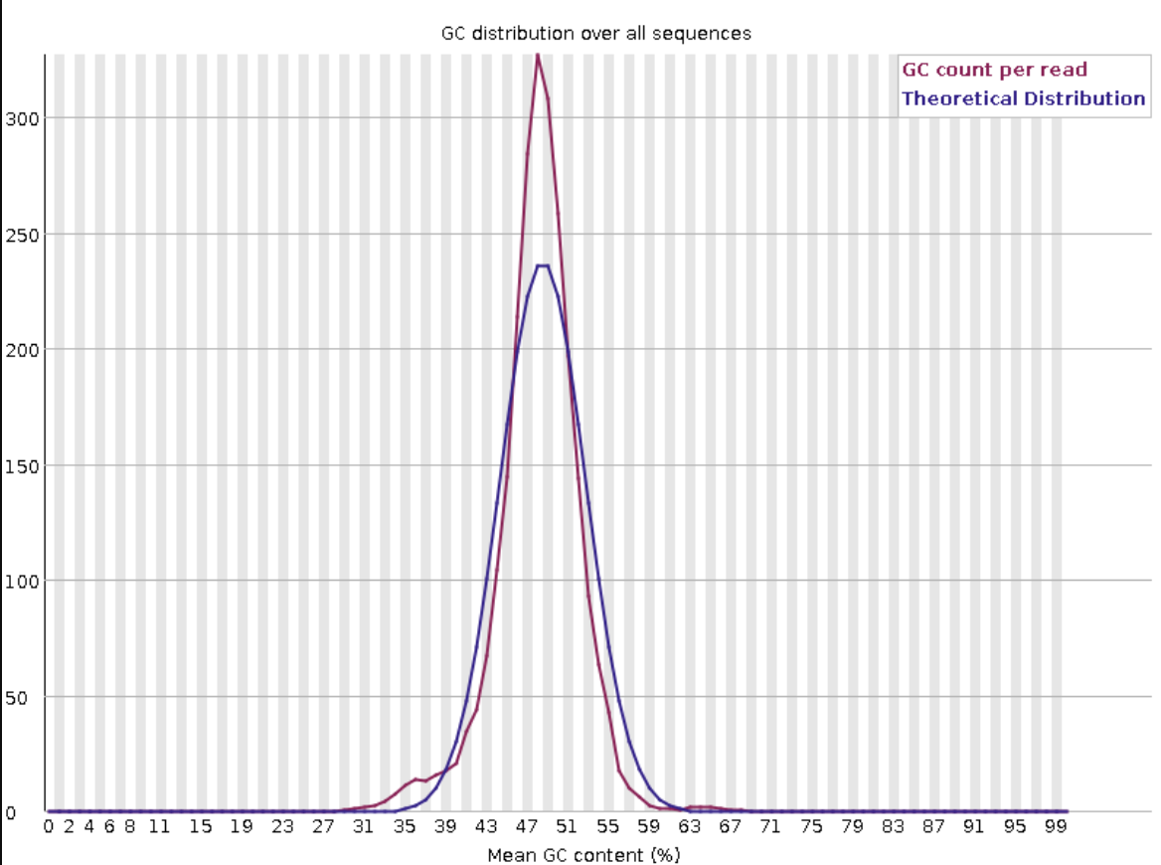
Figure 8. Per-sequence GC content, filtered Nanopore reads (post-Filtlong).

3.4 Genome assembly and quality assessment
Hybrid assembly with Unicycler produced two sequences: a fully circularized chromosome (2,880,082 bp) and a small plasmid (4,645 bp), for a total assembly length of 2,884,727 bp (GC 48.15%). This closely matches the originally published assembly (2.8 Mb chromosome + 4.6 kb plasmid, GC 48.16%).
Metric | Published (Rincón-Rosales et al. 2023) | This assembly
Chromosome length | ~2.8 Mb | 2,880,082 bp (circular)
Plasmid length | ~4.6 kb | 4,645 bp
GC content | 48.16% | 48.15%
Total contigs | 2 (complete) | 2 (complete)
Table 4. Comparison of the independently assembled TSS-3 genome to the originally published assembly.
QUAST alignment of this assembly against the published reference (GCA_029026745.1) confirmed high structural accuracy: 100% genome fraction recovered, 0 misassemblies, a duplication ratio of 1 (no redundant sequence), and low per-base error rates (0.45 mismatches and 0.03 indels per 100 kbp; 0 N's per 100 kbp).
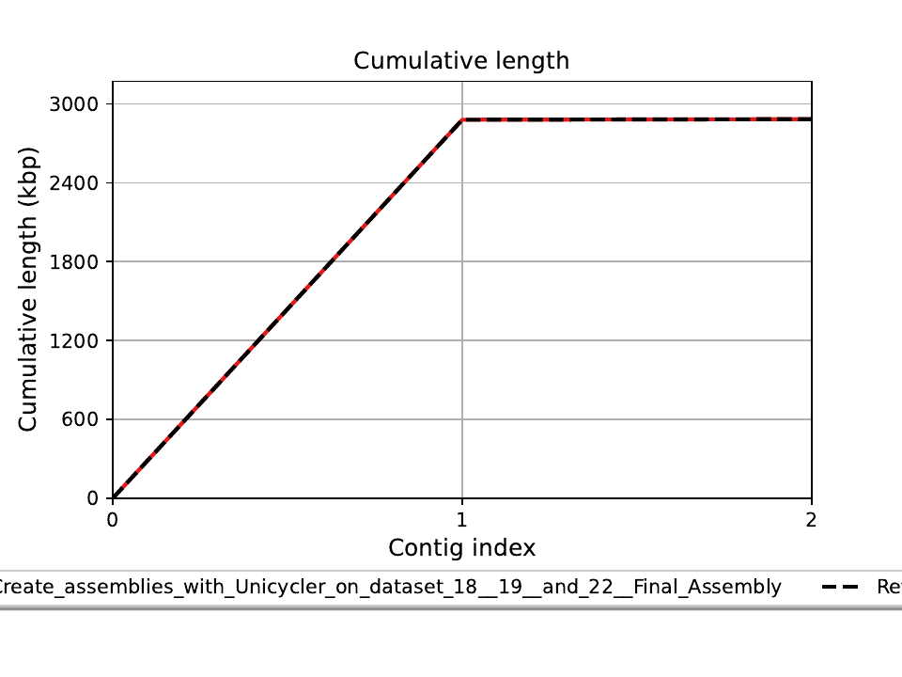
Figure 9. QUAST cumulative length plot: assembled contigs (red) against the reference genome (black dashed), TSS-3 assembly.
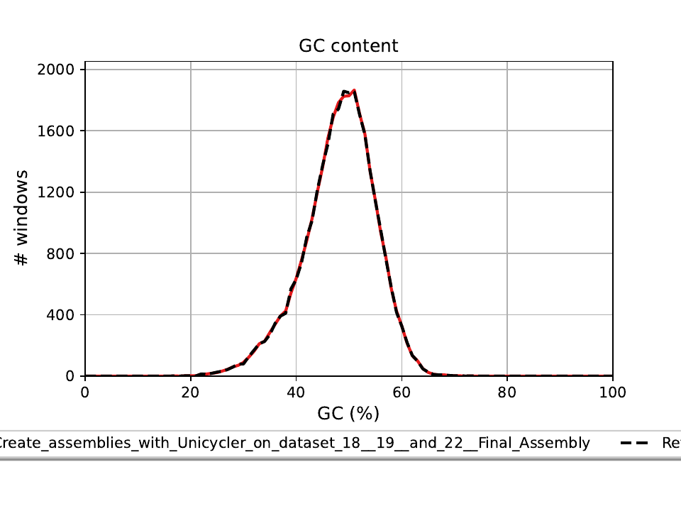
Figure 10. QUAST GC content distribution: assembled contigs (red) against the reference genome (black dashed), TSS-3 assembly.
CheckM lineage-workflow assessment (marker lineage c__Bacilli; 750 reference genomes, 273 marker genes, 152 marker sets) found the assembly to be 99.34% complete with 0.66% contamination (271 of 273 markers present as single copy, 1 present in duplicate, none missing), indicating a highly complete and non-contaminated genome recovery.

3.5 Genome annotation
Prokka annotation identified 2,936 coding sequences (CDS), 27 rRNA genes, 67 tRNA genes, 1 tmRNA gene, and 48 additional ncRNA features across the 2,884,727 bp assembly. The CDS count is closely comparable to the originally published PGAP-based annotation (2,900 CDS; a difference of approximately 1.2%), consistent with expected variation between different gene-calling algorithms rather than a substantive difference in gene content.

3.6 Biosynthetic gene cluster mining
antiSMASH identified two terpene-associated biosynthetic gene cluster (BGC) regions on the chromosome; no BGCs were detected on the plasmid.
Region | Type | Location (bp) | Core biosynthetic genes
1.1 | Terpene-precursor | 1,180,299–1,201,177 | Farnesyl diphosphate synthase, dxs (MEP pathway)
1.2 | Terpene | 2,116,579–2,137,418 | crtB, crtN, crtNb, crtNc
Table 5. Biosynthetic gene cluster regions identified by antiSMASH v8.0.4.
The core biosynthetic genes in Region 1.2 (crtB, 15-cis-phytoene synthase; crtN, 4,4′-diapophytoene desaturase; crtNb, 4,4′-diapolycopene oxygenase; crtNc, 4,4′-diapolycopen-4-al dehydrogenase) correspond to the C30 (diapocarotenoid) branch of bacterial carotenoid biosynthesis, structurally analogous to the staphyloxanthin pathway of Staphylococcus aureus. KnownClusterBlast returned no significant match to any characterized cluster in the MIBiG database for Region 1.2. Region 1.1 returned nominal BLAST hits to several polyketide synthase (PKS) clusters (isoindolinomycin, xantholipin, R1128, pradimicin-A, formicamycin); inspection of the underlying BLAST evidence showed these hits were driven by homology in biotin carboxylase/carboxyl carrier protein genes (accB/accC), which are common housekeeping components shared across many unrelated biosynthetic pathways, and are not interpreted as evidence of PKS-type secondary metabolite production in TSS-3.

3.7 Comparative genomics (Average Nucleotide Identity)
OrthoANIu comparison between the TSS-3 assembly and the E. profundum type strain 10C (GCF_025234635.1) returned an ANI value of 96.21%, exceeding the ≥96% threshold conventionally used for species-level identity. Average aligned length was 1,785,473 bp, with genome coverage of 61.92% (TSS-3) and 65.54% (type strain); the moderate coverage values reflect expected strain-level differences and assembly completeness differences between the two genomes, rather than a lower-confidence species assignment.
Metric | Value
OrthoANIu value | 96.21%
Genome A length (TSS-3) | 2,883,540 bp
Genome B length (10C type strain) | 2,724,420 bp
Average aligned length | 1,785,473 bp
Genome A coverage | 61.92%
Genome B coverage | 65.54%
Table 6. OrthoANIu comparison of TSS-3 against the E. profundum type strain.

4. Discussion
This independent re-analysis reproduces the originally published TSS-3 genome assembly with a high degree of structural and compositional agreement: assembly length, GC content, contig structure, and QUAST-based alignment metrics (100% genome fraction, zero misassemblies) closely match the original publication, and CheckM assessment independently confirms a highly complete, low-contamination genome recovery. This demonstrates that a complete, publication-quality bacterial genome assembly can be reproduced entirely using free, cloud-based computational infrastructure (Galaxy, KBase), without access to institutional high-performance computing.
The identification of a native C30 carotenoid biosynthesis cluster (crtB/crtN/crtNb/crtNc) in TSS-3 confirms that carotenoid production is an intrinsic genomic feature of E. profundum. This provides indirect genomic context for the carotenoid pigments (astaxanthin, lycoxanthin) identified by GC-MS in strain PZ163977. However, a direct mechanistic link should be stated cautiously: the carotenoid pathway identified in TSS-3 is the C30 (diapocarotenoid) branch, whereas astaxanthin and lycoxanthin are C40 carotenoids typically produced via a distinct crtI/crtY/crtZ pathway, which was not detected in this assembly. The genomic and biochemical findings should therefore be read as complementary evidence that E. profundum as a species has carotenoid-producing capacity, rather than as direct confirmation that TSS-3 and PZ163977 share an identical biosynthetic route to the same compounds. Whole-genome sequencing of PZ163977 itself would be needed to confirm whether its C40 carotenoid production involves a distinct crtI/crtY/crtZ-type cluster not present in TSS-3.
The ANI result (96.21%) independently confirms, at the whole-genome level, the species assignment of TSS-3 as E. profundum, consistent with its original 16S rRNA- and genome-based classification. The moderate genome coverage values in the ANI comparison (62–66%) reflect the draft, highly fragmented nature of the type strain reference assembly (deposited as many short contigs) rather than any structural concern with the TSS-3 assembly itself, which was independently confirmed to be complete and correctly structured by QUAST and CheckM.
Several minor practical deviations from the originally planned protocol were required over the course of this project — substituting direct ENA read retrieval for a non-functional Galaxy SRA tool, explicitly specifying Phred33 quality encoding after Trimmomatic's auto-detection failed, and substituting Filtlong for an unavailable NanoFilt installation. Each substitution was verified to produce results consistent with the originally intended method, and is reported transparently in Section 2 rather than presented as though the original tools had been used without issue.

5. Conclusion
This project independently reproduced a complete, high-quality bacterial genome assembly and annotation for E. profundum TSS-3 from public raw sequencing data, using exclusively free, cloud-based bioinformatics platforms. The resulting assembly closely matches the originally published genome in structure, composition, and completeness. Biosynthetic gene cluster mining identified a native C30 carotenoid biosynthesis pathway, providing genomic context — though not a direct compound-level match — for carotenoid-associated anti-inflammatory activity previously characterized experimentally in the related isolate PZ163977. Average Nucleotide Identity analysis further confirmed the species-level identity of TSS-3 relative to the E. profundum type strain. Beyond the specific findings for TSS-3, this project demonstrates a practical, fully reproducible workflow for bacterial comparative genomics that requires no institutional compute infrastructure, and establishes a methodological foundation for future whole-genome sequencing and analysis of strain PZ163977 itself.

References
- Rincón-Rosales, R. et al. (2023). Complete genome sequence of Exiguobacterium profundum strain TSS-3, isolated from a saline-alkaline spring. Microbiology Resource Announcements, 12(7), e00171-23.
- Wick, R. R., Judd, L. M., Gorrie, C. L., & Holt, K. E. (2017). Unicycler: Resolving bacterial genome assemblies from short and long sequencing reads. PLOS Computational Biology, 13(6), e1005595.
- Seemann, T. (2014). Prokka: rapid prokaryotic genome annotation. Bioinformatics, 30(14), 2068–2069.
- Blin, K. et al. (2023). antiSMASH 7.0: new and improved predictions for detection, regulation, chemical structures and visualisation. Nucleic Acids Research, 51(W1), W46–W50.
- Parks, D. H., Imelfort, M., Skennerton, C. T., Hugenholtz, P., & Tyson, G. W. (2015). CheckM: assessing the quality of microbial genomes recovered from isolates, single cells, and metagenomes. Genome Research, 25(7), 1043–1055.
- Gurevich, A., Saveliev, V., Vyahhi, N., & Tesler, G. (2013). QUAST: quality assessment tool for genome assemblies. Bioinformatics, 29(8), 1072–1075.
- Yoon, S. H., Ha, S. M., Lim, J., Kwon, S., & Chun, J. (2017). A large-scale evaluation of algorithms to calculate average nucleotide identity. Antonie van Leeuwenhoek, 110(10), 1281–1286.
[Additional references to be added: PZ163977 dissertation work upon its own publication; BV-BRC comparative genomics study.]

